Continuous Integration and Continuous Deployment Lab

Experiment – 10

**Name : Harivansh Mathur**

**Roll No : R171218043**

**Nexus integration with Jenkins**

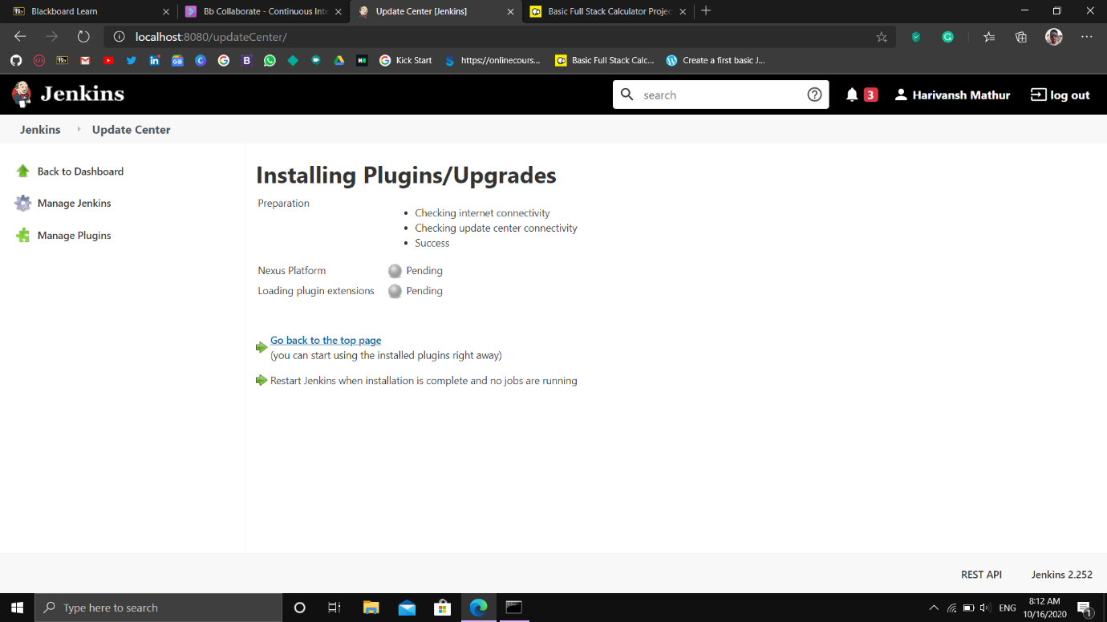

Installing Nexus Platform Plugin in Jenkins

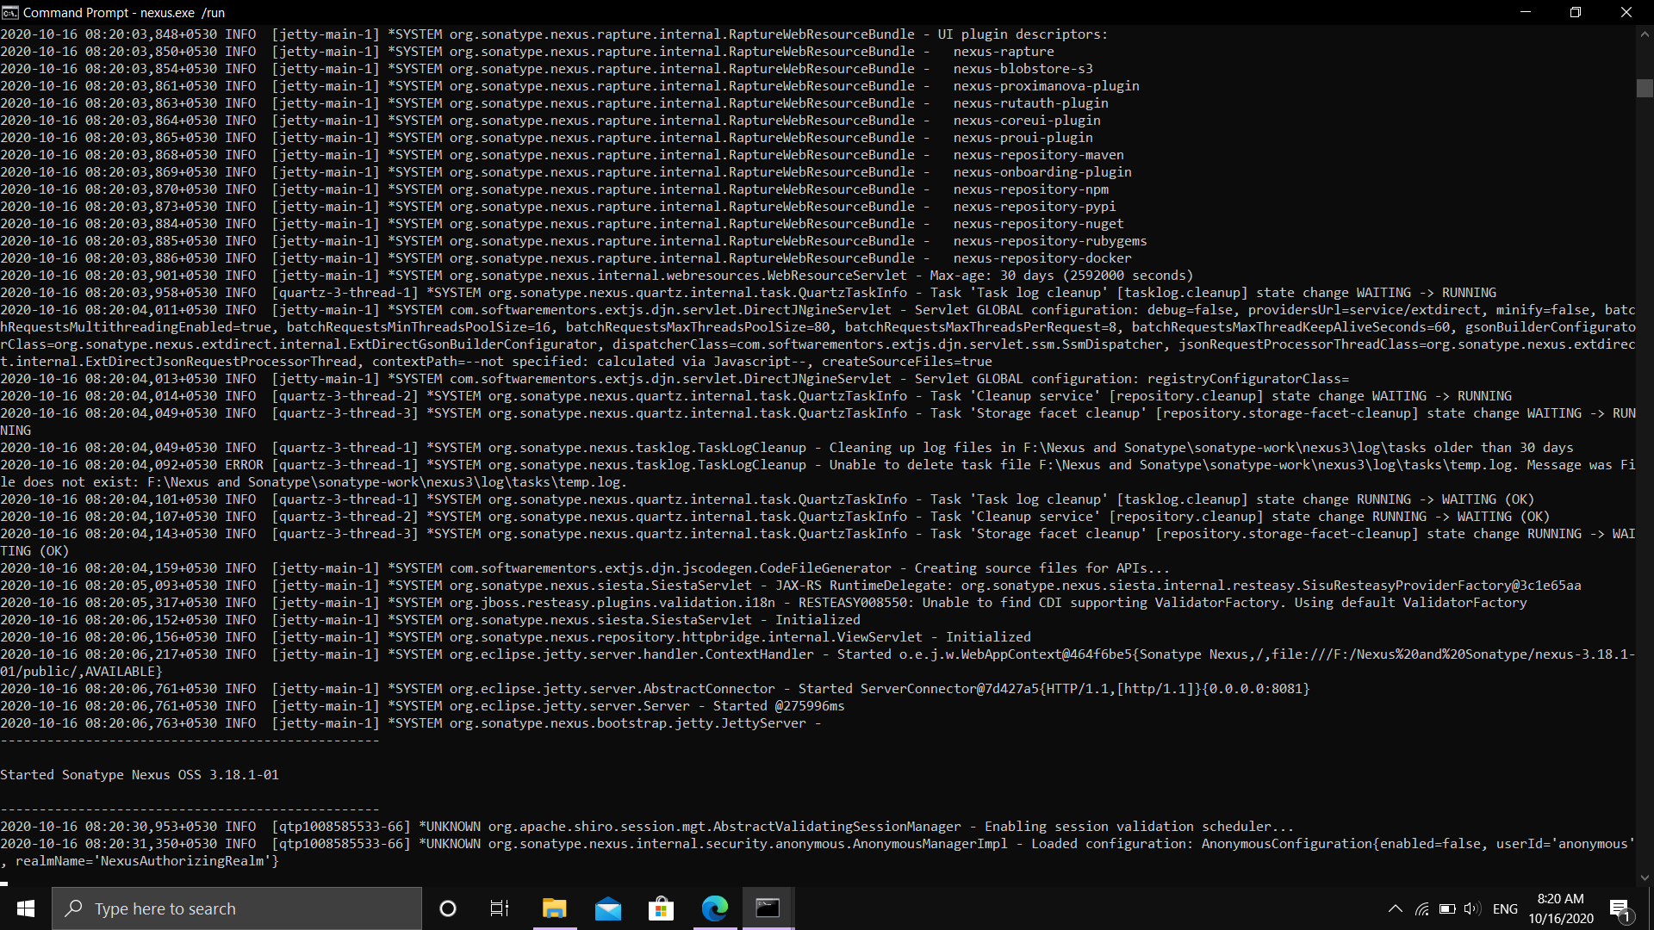

Starting Nexus on my localhost

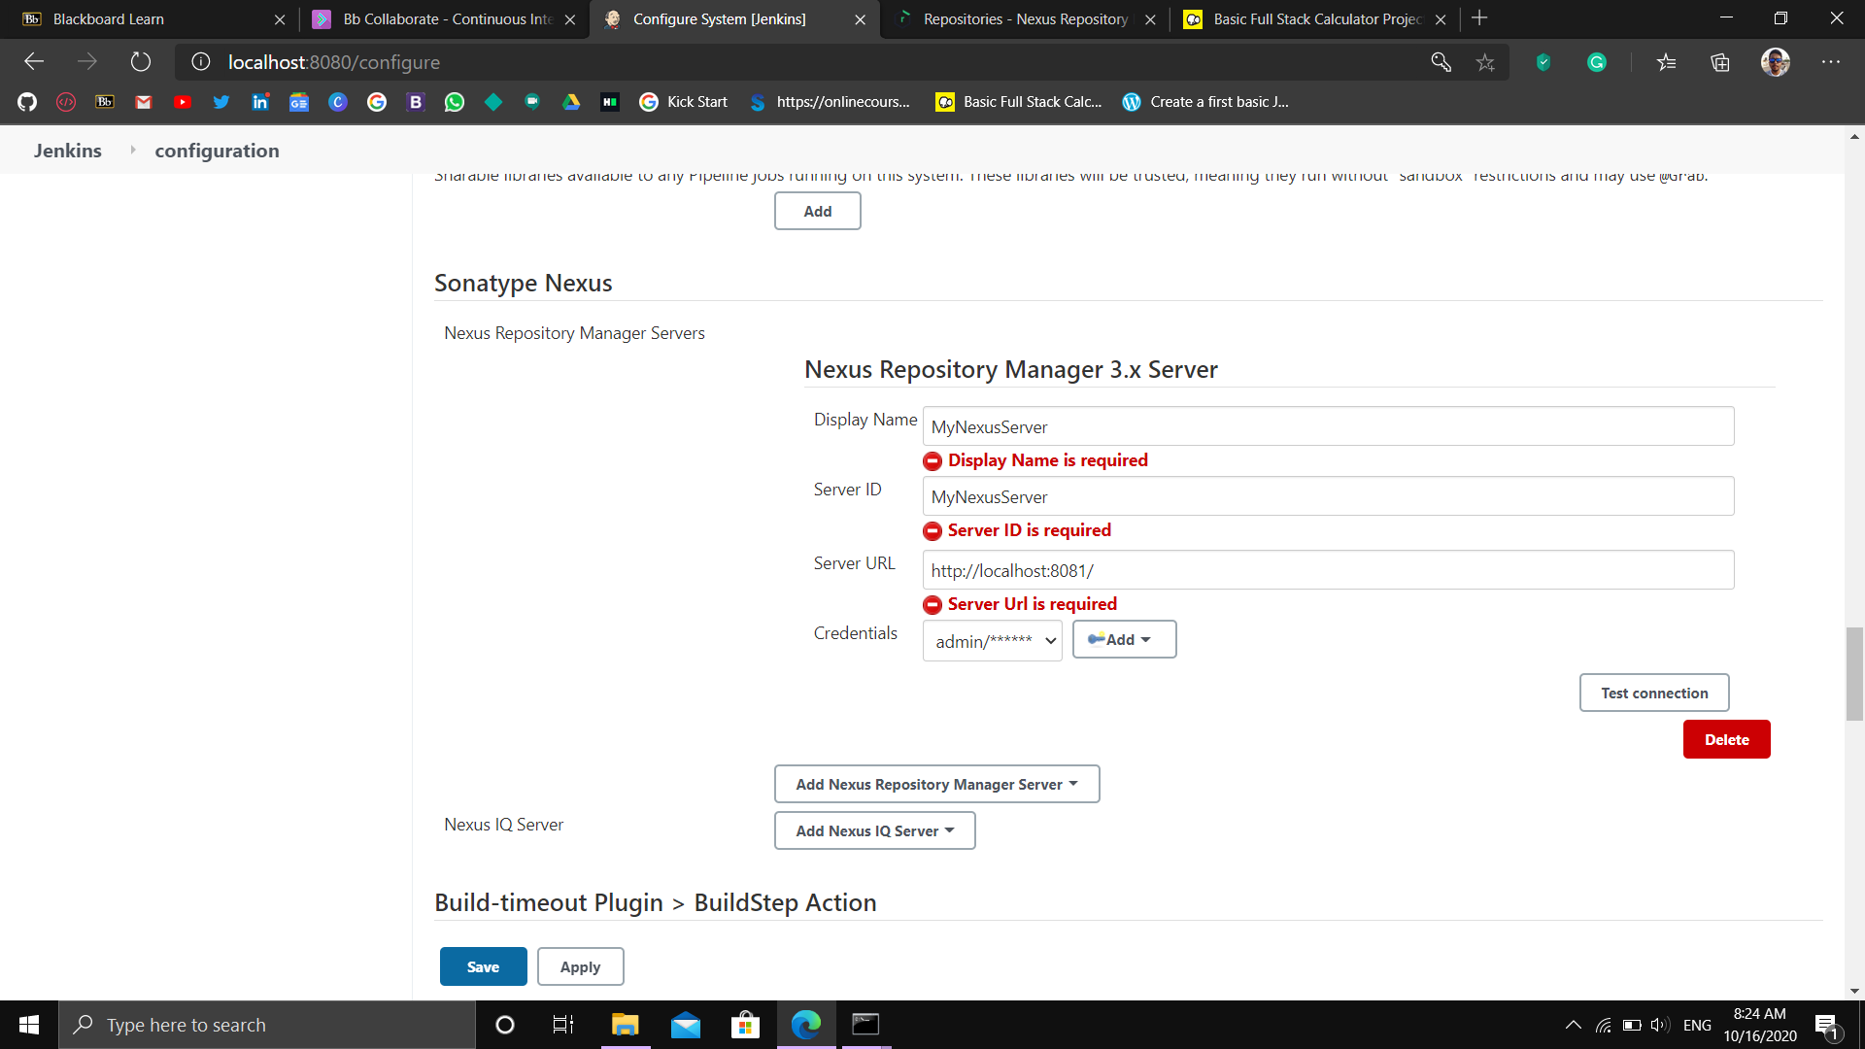

In Jenkins configuration, connecting Jenkins to Nexus by providing url and credentials

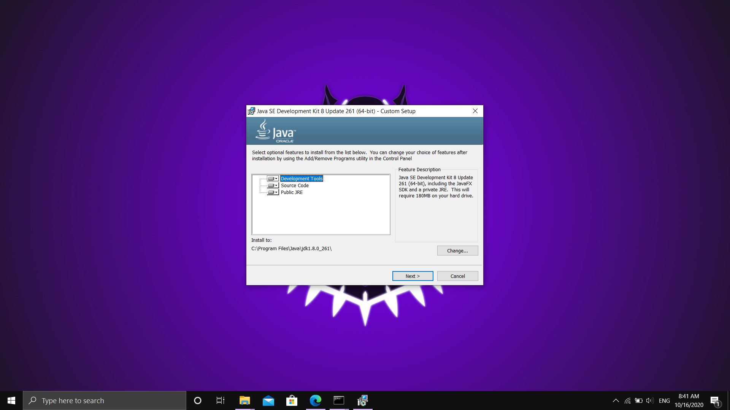

(Also, Nexus does not support Java 11 which was previously installed on my system, therefore installing Java 8 which is supported by Nexus)

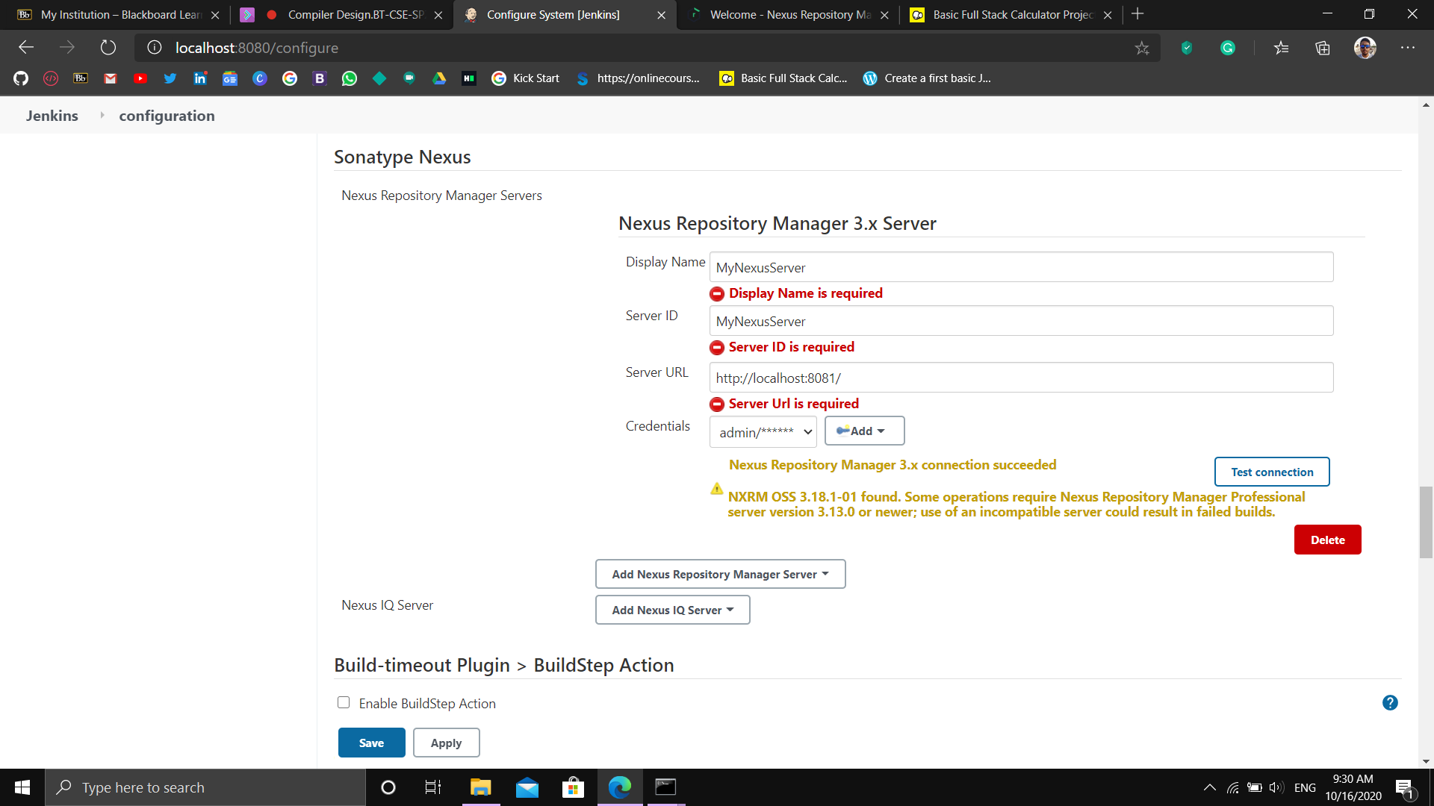

Testing the connection

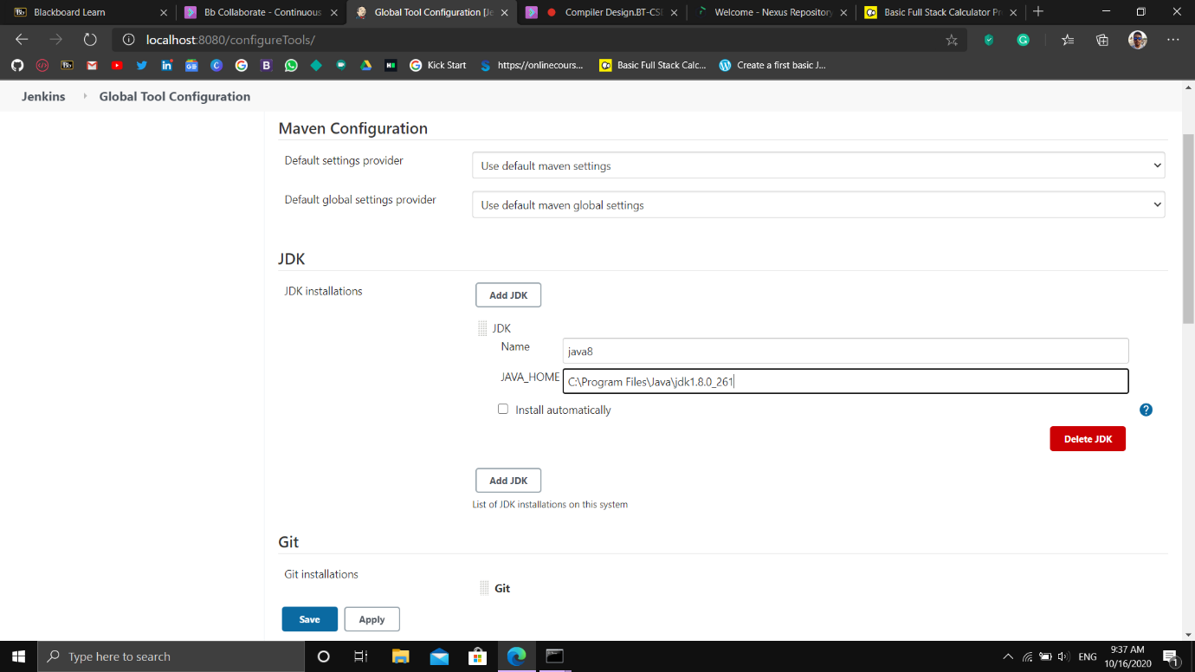

Adding Java (JDK) to my Jenkins

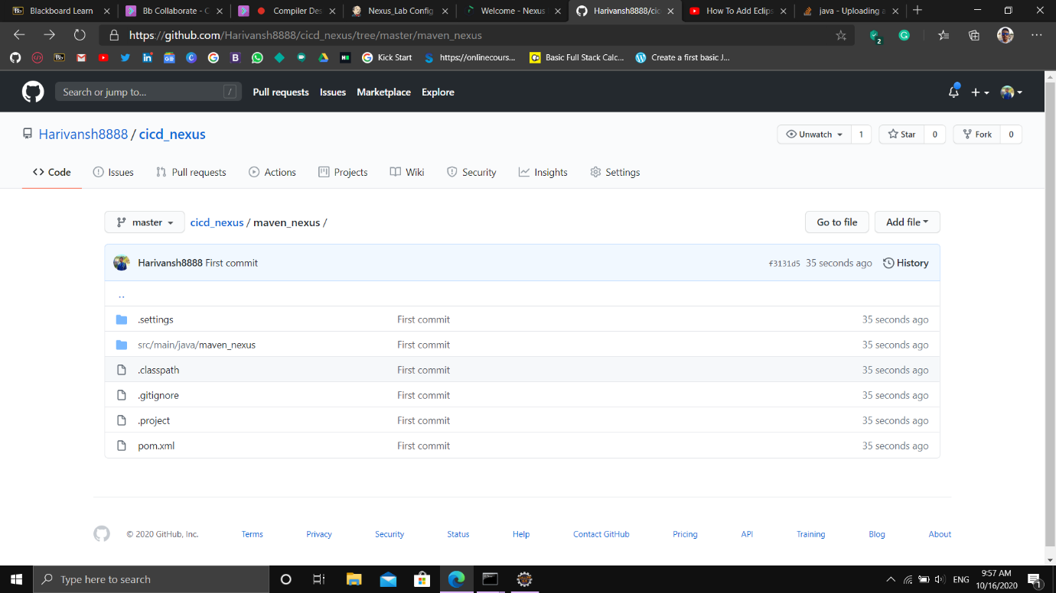

Maven Project Repository on my GitHub

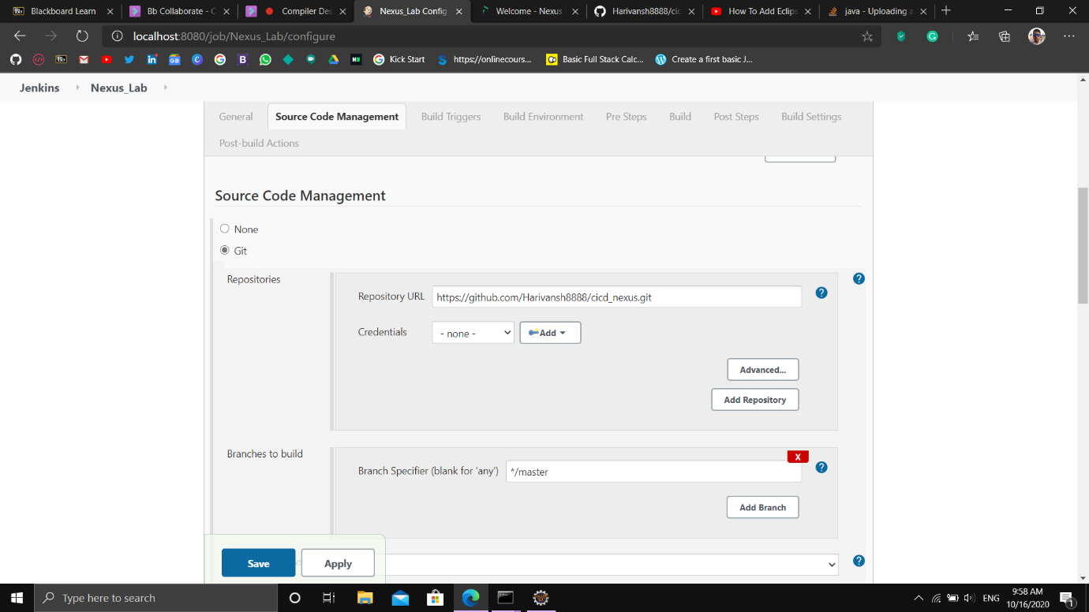

Adding that repository in my newly created maven project item on Jenkins

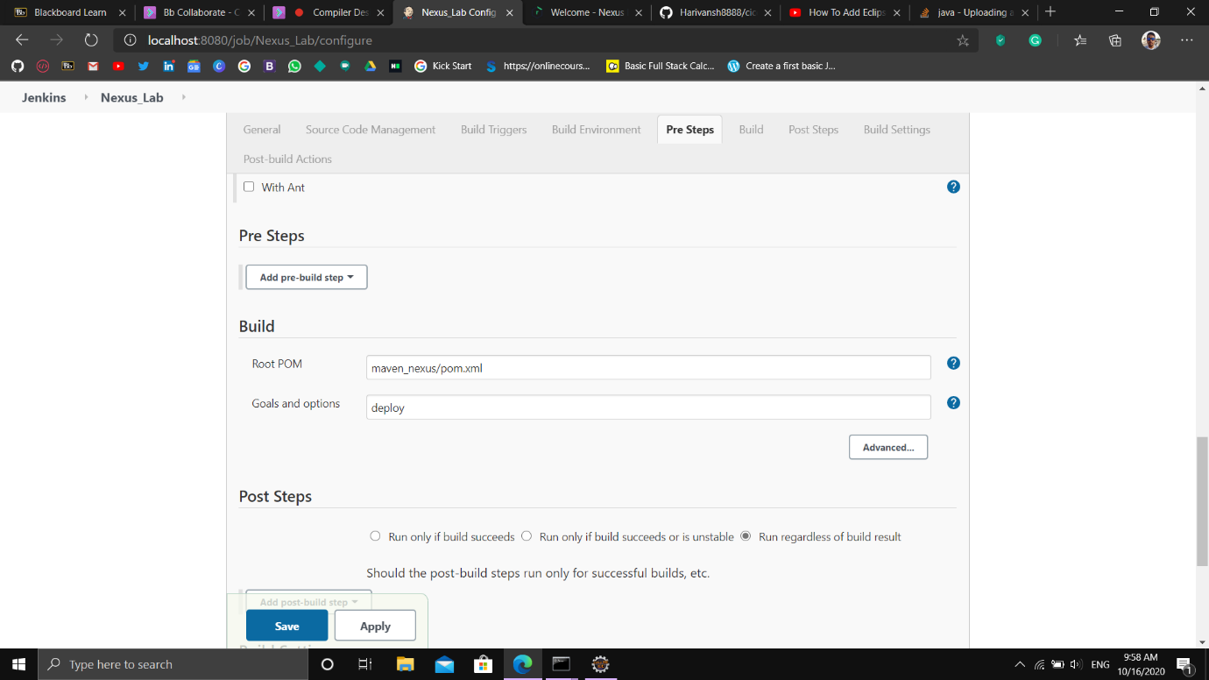

Giving the correct path to POM.xml is important and we are also giving deploy goal here

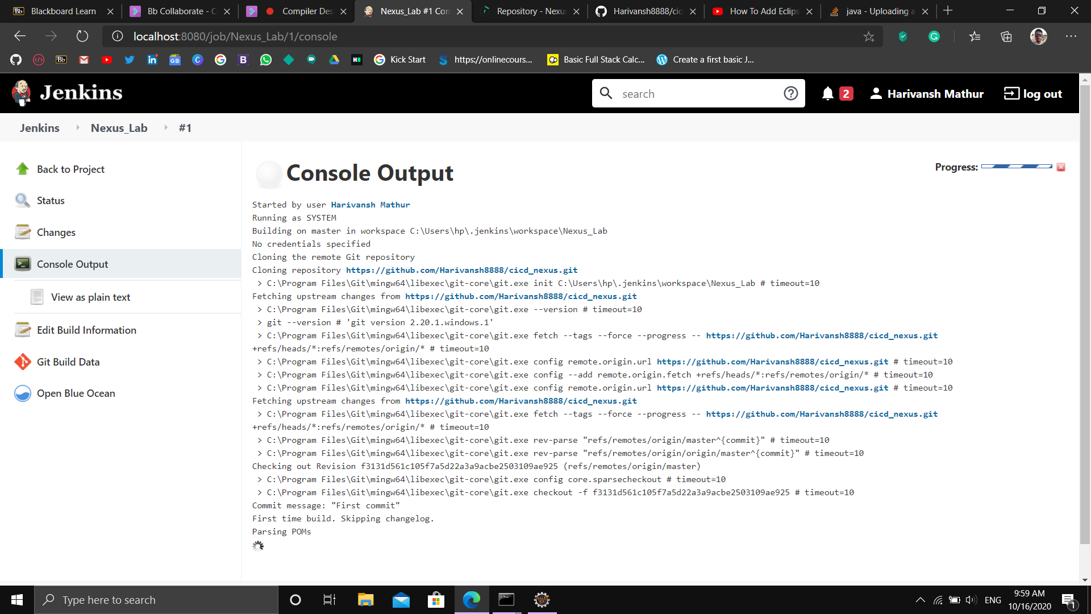

Building this Maven Project

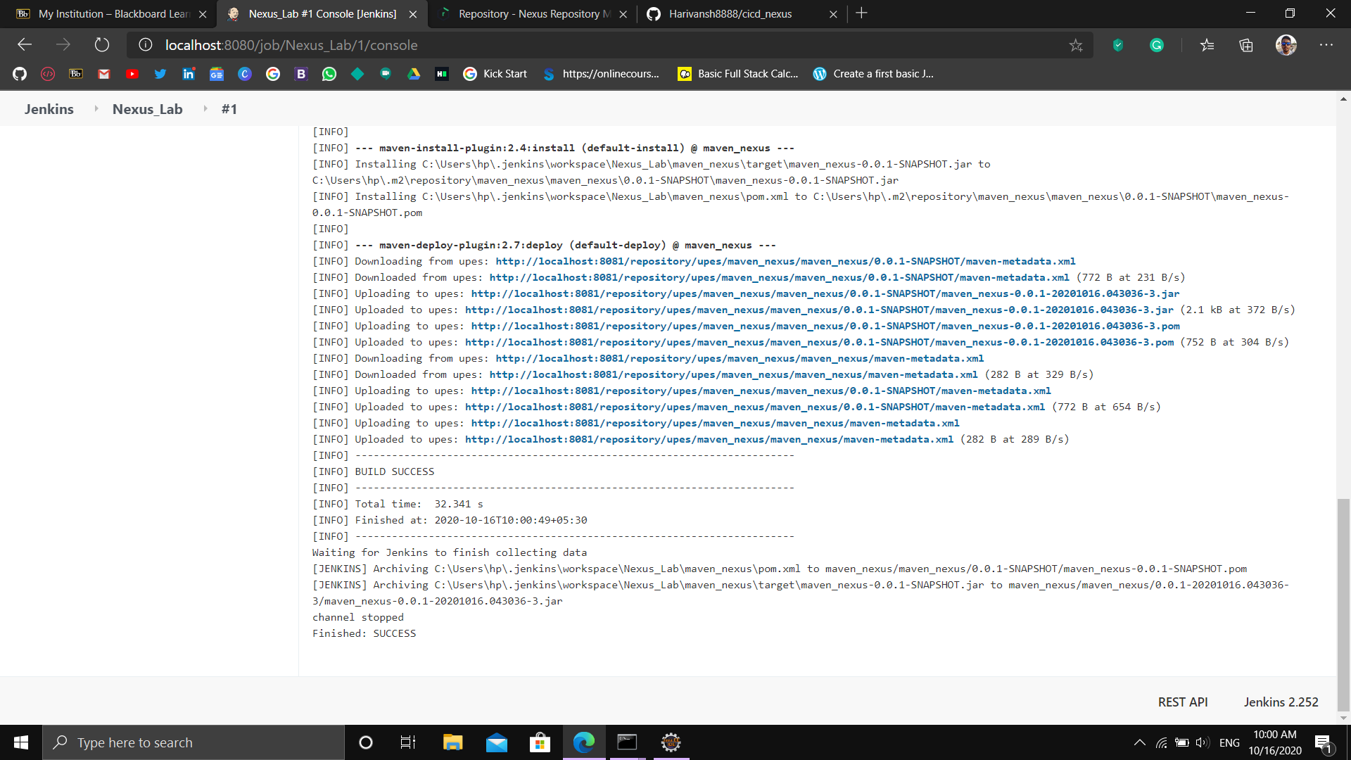

Build Success